**Assignment No.**

**TITLE:** Edge detection using Sobel variants on BBB

**Aim:**

**Write a Python program to grab the image from Camera and apply the edge detection Algorithm with Sobel variants, to find the edges using BBB / ARM Cortex A5/A9/M4 Mobile Boards.**

**Objectives:**

* Capture the image from camera
* Apply edge detection algorithm by using Sobel operator.

**Theory:**

**Definition of Edge:**

An edge can be defined as a set of connected pixels that form a boundary between two disjoint region. Edges are significant local changes of intensity in an image. Edges typically occur on the boundary between two different regions in an image.

**Edge Detection:**

Edge detection is a basic tool used in image processing, basically for feature detection and extraction, which aim to identify points in a digital image where brightness of image changes sharply and find discontinuities. The purpose of edge detection is significantly reducing the amount of data in an image and preserves the structural properties for further image processing. For a noisy image it is difficult to detect edges as both edge and noise contains high frequency contents which results in blurred and distorted result.

In the ideal case, the result of applying an edge detector to an image may lead to a set of connected curves that indicate the boundaries of objects, the boundaries of surface markings as well as curves that correspond to discontinuities in surface orientation. Thus, applying an edge detection algorithm to an image may significantly reduce the amount of data to be processed and may therefore filter out information that may be regarded as less relevant, while preserving the important structural properties of an image. If the edge detection step is successful, the subsequent task of interpreting the information contents in the original image may therefore be substantially simplified. However, it is not always possible to obtain such ideal edges from real life images of moderate complexity.

Edge detection is one of the fundamental steps in image processing, image analysis, image pattern recognition, and computer vision techniques.

**Sobel Operator:**

The Sobel operator, sometimes called Sobel Filter, is used in image processing and computer vision, particularly within edge detection algorithms, and creates an image which emphasizes edges and transitions. It is a discrete differentiation operator, computing an approximation of the gradient of the image intensity function. At each point in the image, the result of the Sobel operator is gradient vector. The Sobel operator is based on convolving the image with a small, separable, and integer valued filter in horizontal and vertical direction and is therefore relatively inexpensive in terms of computations.

**Mathematical Formulation of Edge detection using Sobel Operator:**

1. The operator uses two 3×3 kernels which are convolved with the original image to calculate approximations of the derivatives- one for horizontal changes, and one for vertical.
2. Assume that **A** is the source image, and **G***x* and **G***y* are two images which at each point contain the horizontal and vertical derivative approximations, the computations are as follows:


\mathbf{G}_y = \begin{bmatrix} 
-1 & -2 & -1 \\
 0 & 0 & 0 \\
+1 & +2 & +1 
\end{bmatrix} * \mathbf{A}
\quad
\mbox{and}
\quad   
\mathbf{G}_x = \begin{bmatrix} 
-1 & 0 & +1  \\
\ \ -2 & \ \ 0 & \ \ +2 \\
-1 & 0 & +1 
\end{bmatrix} * \mathbf{A}



where \* here denotes the 2-dimensional convolution operation.

1. Sobel kernels can be decomposed as the products of an averaging and a differentiation kernel, they compute the gradient with smoothing.
2. The *x*-coordinate is defined here as increasing in the "right"-direction, and the *y*-coordinate is defined as increasing in the "down"-direction. At each point in the image, the resulting gradient approximations can be combined to give the gradient magnitude, using:

**Steps for Sobel edge detection method:**

Step 1: Accept the input image.

Step 2: Apply mask Gx,Gy to the input image.

Step 3: Masks manipulation of Gx,Gy separately on the input image.

Step 4: Results combined to find the absolute magnitude of the gradient

\mathbf{G} = \sqrt{ {\mathbf{G}_x}^2 + {\mathbf{G}_y}^2 }

Step 5: The absolute magnitude is the output edges.

Input: A Sample Image

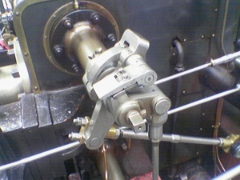

Output: Detected Edges

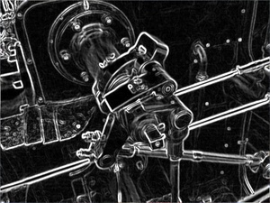

**Conclusion:**

An image is captured using camera and edge is detected using Sobel Algorithm.

**Mathematical Model : (Should be written by Students)**

**FAQ:**

1. Write difference between Sobel and canny operator.
2. Explain in short

1. Prewitt operator

2. Robert Operator.

3. Describe in brief the different python libraries used to implement the program.